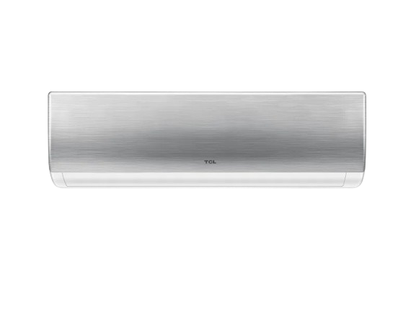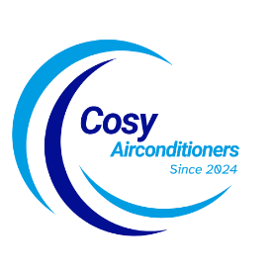

SKU:HSU-18HJ/012USDC(G)

**TAC-T5 Inverter**

~~Rs 125,999.00~~ Rs 104,900.00

Air Purification

Wide Voltage Range With Hyper PCB

Self Cleaning

With adoption of optimized cooling system, the cooling capacity of Haier Air Conditioners still could catch up 100% to provide the best cooling experience to user at 46◦C high temperature.

**Product details**

**THANK YOU!**

**WELLCOME TO OUR WEBSITE**